**MKT 282: Data Analytics & Dynamic Pricing**

**(Raghunath Rao: Fall 2021)**

**Assignment #3**

*This assignment is due by midnight on 11/10/2021. Please paste your answers within this file and save it as "HW3_DP_SOLN" on Canvas at the appropriate place. If you used M.S. Excel/R (or any other statistical software) to arrive at your answers, please submit the relevant files/annotated code as well (so that you can get partial credits for your work even if your answer is incorrect). The scores from your submissions will be reweighted, and you can earn up to 75 points from this exercise.*

*Only one submission per team, please- one person from each team should upload the solution. It is the responsibility of each group to get together and finish the assignment. The team information is available under announcements on Canvas.*

*Late assignments are NOT acceptable.*

**Write the names of your team members here**:

Chloe Estrin, Carter Cowman, Demetri Whitsett, Nihit Parikh

**Optimizing Prices**

This exercise is based on “Fjord Motors” case. Use the dataset “HW3 *FjordMotor_Data.xls*” to analyze and answer the questions below.

Mike Selvage and Dave Tobin are consultants working for a data analytics startup based in Austin TX. They are presently advising Fjord Motor’s B2B sales team in revamping their bidding strategy for fleet sales auctions for their popular model *Coronet Elizabeth*. In the past quarter, Fjord Motors has experimented with about 4,000 bid prices (using managerial intuition and heuristics) and Messrs. Selvage and Tobin have been given access to this data that has the bid price, auction outcome and the order quantity. The MSRP for *Coronet Elizabeth* during the quarter was $25,000 and the total cost per unit can be assumed to be $15,000.

**Part 1A.**  Using the attached datasheet, they fit a two-parameter logit model that best estimates the probability of winning each bid as a function of discount from the list price, assuming a single per unit price will be offered for each bid. The model they fit is:

$ρ(p)=\frac{exp⁡(a+bp)}{1+exp⁡(a+bp)}$.

Where “a” and “b” are the parameters to be estimated and “*ρ*” is the probability of winning the bid. The price p is expressed as a fraction of the MSRP of the $25,000; that is, if Fjord bid $20,000 per unit, p would be equal to 0.8.

1. What are the values of “a” and “b” (obtained by running a logit model)? (2 points)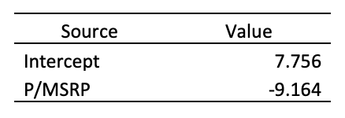

a = 7.756

b = -9.164

1. What is the optimal price Fjord, assuming it is going to offer a single price for each bid? (2 points)

0.83274665 * $25,000 = **$20,818.67**

1. What is the total expected contribution, had Fjord used the price in (2) to bid in all 4,000 auctions? (2 points)

**$241,083,838.33**

1. How does the answer in (3) compare with the actual total contribution received by Fjord by participating in the 4,000 auctions? (2 points)

**The current profits obtained by Fjord by participating in 4000 auctions = $171,829,002**

**The expected profits obtained by Fjord by participating in 4000 auctions = 241,083,838**

**This shows an 40.30% improvement over the original profits value of $171,829,002.**

**Part 1B**. As Messrs. Selvage and Tobin continue their deliberations with Fjord sales team, they discovered that bids 1 through 2,000 were to various police departments, and that bids 2,001 through 4,000 were to corporate buyers. Using this new piece of information, they estimate two separate two-parameter logit models, one for police departments and one for corporate buyers. The model they are fitting is the same as in 1A, but the values of “a” and “b” for the police will be different than the values of “a” and “b” for corporate buyers.

1. What are the corresponding values for “a” and “b” for each type of buyers?

1.1. First estimate these values by splitting the data into two parts- one dataset for police department bids and another dataset for corporate buyers. (8 points)

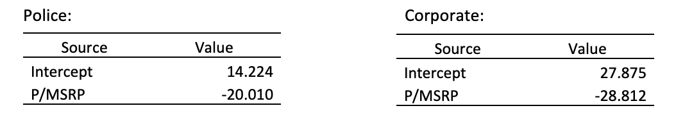

1.2. Now estimate these values using the entire data but creating a dummy variable “police” and an interaction variable for “police” and “p”. Paste these results and show that these estimates are equivalent to the ones obtained in 1.1. (6 points)

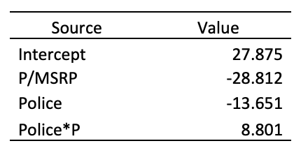

If Police = 0, the Police and Police*P variables = 0 and the intercept (27.875) and P/MSRP variable (-28.812) are the same as the corporate only model.

If Police = 1, the intercept (27.875) plus the Police dummy variable (-13.651) = the intercept of the police only model (14.224). Also, the P/MSRP (-28.812) plus the Police*P interaction term (8.801) = the P/MSRP variable from the Police only model (-20.010).

1. What are the optimal prices Fjord should offer to police and corporate buyers respectively? (8 points)

Police = 0.706 * $25,000 = **$17,638.53**

Corporate = 0.897 * $25,000 = **$22,431.48**

1. What would the total expected contribution have been if Fjord had used this pricing in the 4,000 bids? (4 points)

**$308,695,835.83**

1. What is the improvement in the total expected contribution over the actual total contribution and over the outcome in 1A where one cannot differentiate between the buyers? (4 points)

Improvement from the contribution that was actual total contribution is $136,866,833.83, which is a 79.65% improvement over the original $171,829,002.

Improvement over the outcome in 1A where one cannot differentiate between the buyers and being able to differentiate between buyers and being able to differentiate is a $67,611,997.50, which is a 28.05% improvement over 1A’s contribution of $241,083,838.33

1. Based on this analysis, provide a qualitative advice to Fjord motors on re-tuning their bidding strategy. (4 points)

*(Hint: You should tell them for each type of the buyer whether they should be bidding more aggressively, or more conservatively compared to what they have been doing).*

The obtained optimal bid price for police departments is $17,638.53, which is less than the optimal bid price for the overall model we found in 1A ($20,818.67). Therefore we propose bidding more conservatively by giving them a larger discount. The optimal bid price for corporate purchasers is $22,431.48, which is higher than the optimal bid price for the overall model we found in 1A ($20,818.67). Therefore, we recommend bidding more aggressively by offering corporate buyers less of a discount.

**Part 1C**. Their discussions with the sales team reveal that order size is an important determinant for the buyers’ price sensitivity with buyers ordering larger order fleet sizes being more sensitive to the prices. Messrs. Selvage and Tobin add a new parameter “e” to capture this effect. Their new model is:

$ρ(p)=\frac{exp⁡(a+b*p+c*Police+d*\left(p*Police\right)+e*s)}{1+exp⁡(a+b*p+c*Police+d*\left(p*Police\right)+e*s)}$.

Where, “s” is the number of vehicles in the order and “e” is the corresponding parameter to be estimated. (Note: Run a single model with the entire data as in part #1.2 in 1B but also include a variable “Size” denoting the order size).

1. Estimate the values “a”, “b”, “c” “d” and “e”. Interpret the coefficient “e”. (12 points)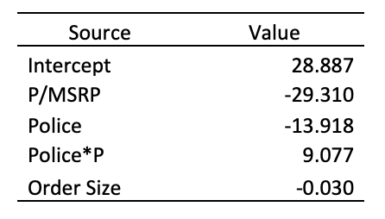

**The coefficient E is how much the overall predicted score will decrease for each additional unit in the order size.**

1. What optimal prices should Fjord charge for orders of 20 cars and for the orders of 40 cars to police departments and to corporate purchasers respectively? (Your need to come up with four prices) (8 points)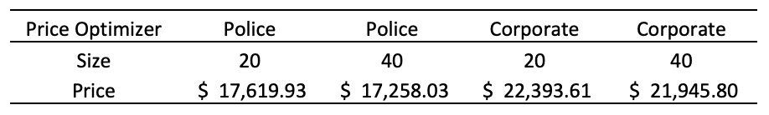

Optimal price for Fjord for orders of 20 cars for police departments: $17,619.93

Optimal price for Fjord for orders of 40 cars for police departments: $17,258.03

Optimal price for Fjord for orders of 20 cars for corporate purchasers: $22,393.61

Optimal price for Fjord for orders of 20 cars for corporate purchasers: $21,945.80

1. If Fjord Motors had followed this analysis in bidding for each of the 4,000 historic bids, what would its total contribution margin would have been? How does this compare with the total contribution margin in 1B? (30 points)

Total contribution margin using this method: **$303,220,679.86**

This is a $5,475,155.97 or 1.77% decrease from the total contribution margin calculated in 1B.

**Part 1D**. As they are wrapping up their recommendations, Messrs. Selvage and Tobin discover that *Coronet Elizabeth* model sold to police departments is somewhat different from that sold to corporate fleets. Specifically, the police model includes a slightly souped-up engine, bullet proof glass in all windows, a metal grill separating the front and the back seats, and plastic cup holders for both front seats. As a result, the police version of *Coronet Elizabeth* costs $16,000 to manufacture versus $15,000 for the corporate version. How would this change the optimal price charged to police departments for fleets of 20 and 40 cars (compared to the ones charged in 1C)? (8 points)

*(Hint: You do not need to run any new logit models to answer this question)*

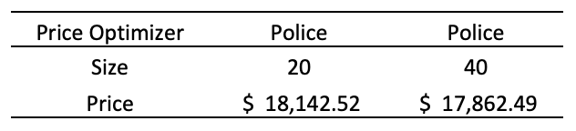

The optimal bid price for police department for fleets of 20 is higher in 1D than in 1C by $522.59 ($18,142.52 - $17,619.93) and similarly, for fleets of 40, the optimal bid price is higher in 1D than in 1C by $604.46 ($17,862.49 - 17,258.03). This is due to the fact that the manufacturing cost for police department fleets has increased by $1,000 in 1D compared to the manufacturing cost in 1C. That is why the model is charging a higher price to the police departments in 1D.